Project ID: 2017-2121
Lab Hub: Mount Sinai CHEAR Network Laboratory Hub
Project Name: The Dynamics of Exposure, Phthalates and Asthma in a Randomized Trial (DEPART)
Project PI: Dr. Karr
Description of Analyses:
A Competitive ELISA for oxidative stress in biological samples
8-Hydroxy-2’-deoxyguanosine, 8-iso Prostaglandin F2α and Leukotriene E4 were measured using a competitive ELISA kits following the manufactures’ recommendations. Briefly, all three analytes of interest were measured based on the competition between the analytes of interest and 8-OH-dG-acetylcholinesterase (AchE) conjugated analyte tracer for the target specific antibodies. For an examples, 8-Hydroxy-2’-deoxyguanosine was measured using High Sensitivity ELISA Kit (1180 E. Ellsworth Rd · Ann Arbor, MI · USA. Because the amount of tracer is held constant while the concentration of oxidatively damaged guanine varies, the amount of tracer that is able to bind to the monoclonal antibody is inversely proportional to the concentration of oxidatively damaged guanine in the assay well. This antibody-oxidatively damaged guanine complex binds to the goat polyclonal anti-mouse IgG that has been previously attached to the assay well. The plate is washed to remove any unbound reagents and then substrate to AChE is added to the well. The product of this enzymatic reaction has a distinct yellow color and absorbs strongly at 412 nm. The intensity of this color, determined spectrophotometrically, is proportional to the amount of 8-Hydroxy-2’-deoxyguanosine Tracer bound to the well, which is inversely proportional to the amount of free 8-OH-dG present in the well during the incubation.
Briefly, biological samples (urine) were measured at least at a minimum of two dilutions with each dilution assayed in triplicates. In assay plate, samples 50 μl were combined with 8-Hydroxy-2’-deoxyguanosine AChE Tracer 50 μl and 8-Hydroxy-2’-deoxyguanosine ELISA Monoclonal Antibody 50 μl to each well. Assay plates were then incubated 18 hours at 4°C. Plates were then washed off the unbound reagents and incubate with freshly reconstituted AChE substrate by using an orbital shaker equipped with a large, flat cover to allow the plates to develop the color in the dark for 90 minutes. Plates were then read at a wavelength at 412 nm when the absorbance of the B₀ wells (Maximum binding) are in the range of 0.3-1.0 A.U. (blank subtracted) by spectrometer (SpectraMax L Mciroplate reader, Molecular Devices LLC, San Jose, California 95134). Standard Curve is plotted by %B/B₀ for standards versus 8-hydroxy-2’-deoxyguanosine concentration using linear (y) and log (x) axes and perform a 4-parameter logistic fit. Sample Concentration was then calculated by the B/B0 (or %B/B0) value for each sample. Determine the concentration of each sample using the equation obtained from the standard curve plot. Assay performance quality Control (QC) was determined by analysis of the standards provided for each kit for the inter- and intra-assay co-efficient variance and interpolate calibrators.

- 8-Hydroxy-2’-deoxyguanosine
Figure 1. Typical standard binding curve is shown here with %Binding (B)/Maximum binding (B₀)in Y axis and amount of 8-Hydroxy-2-guanosine (pg/ml) in X-axis. | 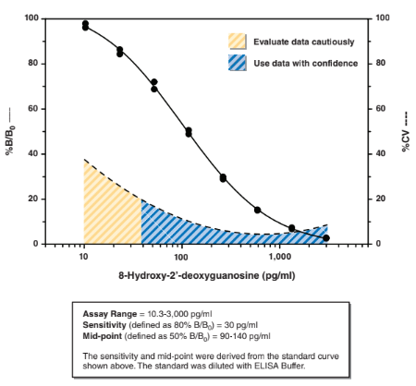

Table 1. The precision of inter- and intra-assay CVs of standards curve data points. % CV represents the variation in measured concentration. Ϯ Outside of the recommended usable range of the assay. | 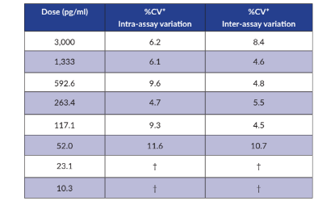

Table 2. The cross reactivity of the assay with the compounds of Guanosine derivatives. | 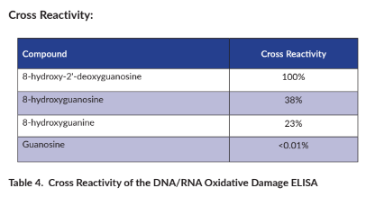
- 8-iso Prostaglandin F2α ELISA measures with a range from 0.8-500 pg/ml and a sensitivity (80% B/B0) of approximately 3 pg/ml.

Figure 1. Typical binding curve is shown here with %Binding (B)/Maximum binding (B₀)in Y axis and amount of 8-iso Prostaglandin F2α (pg/ml) in X-axis. | 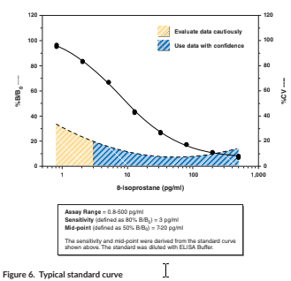

Table 1. The precision of inter- and intra-assay 8-iso Prostaglandin F2α CVs of standards curve data points. % CV represents the variation in measured concentration. Ϯ Outside of the recommended usable range of the assay. | 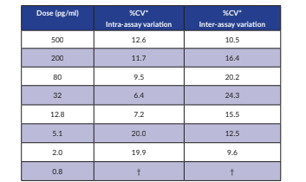

Table 2. Cross Reactivity of 8-iso Prostaglandin F2α  and its derivatives | 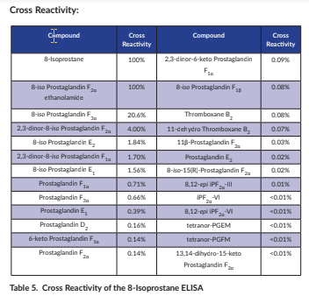

- Leukotriene E4 was measured from urine without a purification step. The assay has a range of 7.8-1,000 pg/ml and a sensitivity (80%B/B0) of approximately 25 pg/ml.
Figure 1. Typical binding curve is shown here with % Binding (B)/Maximum binding (B₀) in Y axis and amount of 4-Leukotriene (LTE₄) (pg/ml) in X-axis. | 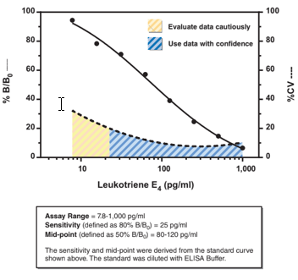

Table 1. The precision of inter- and intra-assay Leukotriene CVs of standards curve data points. % CV represents the variation in measured concentration. Ϯ Outside of the recommended usable range of the assay. | 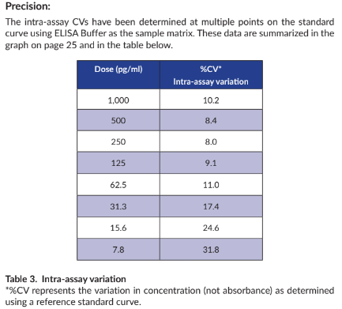

Table 2. Cross Reactivity of Leukotriene E4 (LTE₄) and its derivatives | 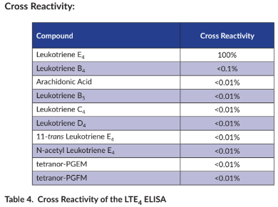

Key words
Blank: background absorbance caused by Ellman’s Reagent. The blank absorbance should be subtracted from the absorbance readings of all the other wells, including NSB wells.
Total Activity: total enzymatic activity of the AChE-linked tracer.
NSB (Non-Specific Binding): non-immunological binding of the tracer to the well. Even in the absence of specific antibody a very small amount of tracer still binds to the well; the NSB is a measure of this low binding. Do not forget to subtract the Blank absorbance values.
B0 (Maximum Binding): maximum amount of the tracer that the antibody can bind in the absence of free analyte.
%B/B0 (%Bound/Maximum Bound): ratio of the absorbance of a particular sample or standard well to that of the maximum binding (B0) well.
Standard Curve: a plot of the %B/B0 values versus concentration of a series of wells containing various known amounts of analyte.
Cross Reactivity: numerical representation of the relative reactivity of this assay towards structurally related molecules as compared to the primary analyte of interest. Biomolecules that possess similar epitopes to the analyte can compete with the assay tracer for binding to the primary antibody. Substances that are superior to the analyte in displacing the tracer result in a cross reactivity that is greater than 100%. Substances that are inferior to the primary analyte in displacing the tracer result in a cross reactivity that is less than 100%. Cross reactivity is calculated by comparing the mid-point (50% B/B0) value of the tested molecule to the mid-point (50% B/B0) value of the primary analyte when each is measured in assay buffer using the following formula:
% Cross Reactivity = (50% B/B0 value for the primary analyte/50% B/B0 value for the potential cross reactant) x 100%

